EXPERIMENT 1
RecursiveLinearSearch
#include <stdio.h>
#include <time.h>

int RecursiveLinearSearch(int arr[], int key, int index)
{
if (index >= 100000)
return -1;
if (arr[index] == key)
return index;
return RecursiveLinearSearch(arr, key, index + 1);
}

int main()
{
int n = 100000;
int arr[n];
for (int i = 0; i < n; i++)
arr[i] = i;

int key = 99999;
clock_t start, end;
double cpu_time_used;

start = clock();
int result = RecursiveLinearSearch(arr, key, 0);
end = clock();

cpu_time_used = ((double)(end - start)) / CLOCKS_PER_SEC;

if (result != -1)
printf("Element found at index %d\n", result);
else
printf("Element not found\n");

printf("Execution time: %f seconds\n", cpu_time_used);

return 0;
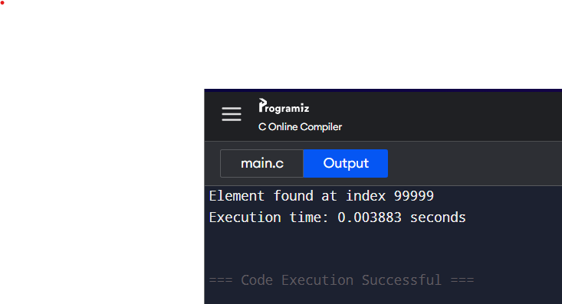
}

1B)BinarySearch
#include <stdio.h>
#include <time.h>

int BinarySearch (int arr[], int n, int key)
{
int low = 0, high = n - 1;
while (low <= high)
{
int mid = low + (high - low) / 2;

if (arr[mid] == key)
return mid;
else if (arr[mid] < key)
low = mid + 1;
else
high = mid - 1;
}
return -1;
}

int main()
{
int n = 100000;
int arr[n];
for (int i = 0; i < n; i++)
arr[i] = i;

int key = 99999;
clock_t start, end;
double CPU_time_used;

start = clock();
int Result = BinarySearch(arr, n, key);
end = clock();

CPU_time_used = ((double)(end - start)) / CLOCKS_PER_SEC;

if (Result != -1)
printf("Element found at index %d\n", Result);
else
printf("Element not found\n");

printf("Execution time: %f seconds\n", CPU_time_used);

return 0;
}
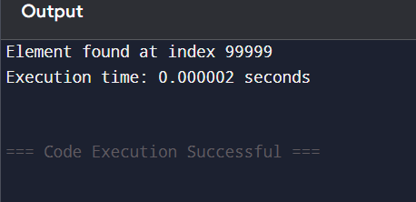

IC) Binarysearch-recursionfunction
#include <stdio.h>
#include <time.h>

int RecursiveBinarySearch(int arr[], int low, int high, int key)
{
if (low > high)
return -1;

int mid = (low + high) / 2;

if (arr[mid] == key)
return mid;
else if (arr[mid] > key)
return RecursiveBinarySearch(arr, low, mid - 1, key);
else
return RecursiveBinarySearch(arr, mid + 1, high, key);
}

int main()
{
int n = 100000;
int arr[n];
for (int i = 0; i < n; i++)
arr[i] = i;

int key = 99999;
clock_t start, end;
double cpu_time_used;

start = clock();
int Result = RecursiveBinarySearch(arr, 0, n - 1, key);
end = clock();

cpu_time_used = ((double)(end - start)) / CLOCKS_PER_SEC;

if (Result != -1)
printf("Element found at index %d\n", Result);
else
printf("Element not found\n");

printf("Execution time: %f seconds\n", cpu_time_used);

return 0;
}

EXPERIMENT 2
INSERTION SORTING
#include <stdio.h>
#include <time.h>

void InsertionSort(int array[], int n)
{
int i, element, j;
for (i = 1; i < n; i++)
{
element = array[i];
j = i - 1;
while (j >= 0 && array[j] > element)
{
array[j + 1] = array[j];
j = j - 1;
}
array[j + 1] = element;
}
}
void PrintArray(int array[], int n)
{
int i;
for (i = 0; i < n; i++)
printf("%d ", array[i]);
printf("\n");
}

int main()
{
int arr[] = {50, 23, 9, 18, 61, 32};
int n = sizeof(arr) / sizeof(arr[0]);

clock_t start, end;
double cpu_time_used;

printf("\nBefore Sorting:\n");
PrintArray(arr, n);
start = clock(); // Start time
InsertionSort(arr, n);
end = clock(); // End time
cpu_time_used = ((double)(end - start)) / CLOCKS_PER_SEC;
printf("\nAfter Sorting:\n");
PrintArray(arr, n);
printf("\nExecution Time: %f seconds\n", cpu_time_used);
return 0;
}
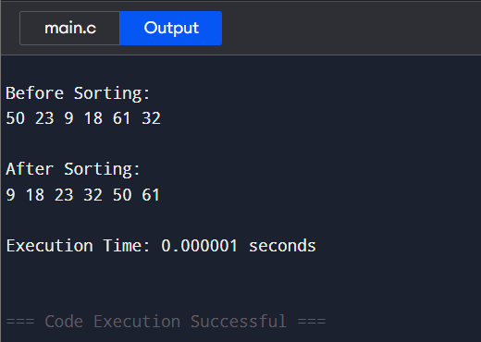
2B Minimum and Maximum
#include <stdio.h>
#include <time.h>

struct Pair
{
int max;
int min;
};

struct Pair maxMinDivideConquer(int arr[], int low, int high)
{
struct Pair result;
struct Pair left;
struct Pair right;
int mid;

if (low == high)
{
result.max = arr[low];
result.min = arr[low];
return result;
}

if (high == low + 1)
{
if (arr[low] < arr[high])
{
result.min = arr[low];
result.max = arr[high];
}
else
{
result.min = arr[high];
result.max = arr[low];
}
return result;
}

mid = (low + high) / 2;
left = maxMinDivideConquer(arr, low, mid);
right = maxMinDivideConquer(arr, mid + 1, high);

result.max = (left.max > right.max) ? left.max : right.max;
result.min = (left.min < right.min) ? left.min : right.min;

return result;
}

int main()
{
int arr[] = {56, 4, 26, 83, 64, 46};
int n = sizeof(arr) / sizeof(arr[0]);
struct Pair result;
clock_t start, end;
double cpu_time_used;

start = clock(); // Start time
result = maxMinDivideConquer(arr, 0, n - 1);
end = clock(); // End time

cpu_time_used = ((double)(end - start)) / CLOCKS_PER_SEC;

printf("Maximum element is: %d\n", result.max);
printf("Minimum element is: %d\n", result.min);
printf("Execution time: %f seconds\n", cpu_time_used);

return 0;
}
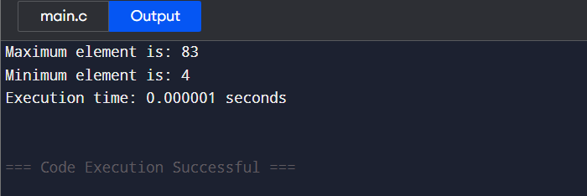

EXPERIMENT 3
Merge sort
#include <stdio.h>
#include <stdlib.h>
#include <time.h>

// Function to merge two sorted subarrays
void merge(int arr[], int left, int mid, int right) {
int i, j, k;
int n1 = mid - left + 1;
int n2 = right - mid;
int *L = (int *)malloc(n1 * sizeof(int));
int *R = (int *)malloc(n2 * sizeof(int));

for (i = 0; i < n1; i++)
L[i] = arr[left + i];
for (j = 0; j < n2; j++)
R[j] = arr[mid + 1 + j];

i = 0; j = 0; k = left;
while (i < n1 && j < n2) {
if (L[i] <= R[j])
arr[k++] = L[i++];
else
arr[k++] = R[j++];
}
while (i < n1) arr[k++] = L[i++];
while (j < n2) arr[k++] = R[j++];

free(L);
free(R);
}

// Function to perform Merge Sort
void mergeSort(int arr[], int left, int right) {
if (left < right) {
int mid = left + (right - left) / 2;
mergeSort(arr, left, mid);
mergeSort(arr, mid + 1, right);
merge(arr, left, mid, right);
}
}

// Function to print an array
void printArray(int arr[], int size) {
for (int i = 0; i < size; i++)
printf("%d ", arr[i]);
printf("\n");
}

// Main function
int main() {
int arr[] = {12, 11, 13, 5, 6, 7};
int arr_size = sizeof(arr) / sizeof(arr[0]);
clock_t start, end;
double cpu_time_used;

printf("Given array is:\n");
printArray(arr, arr_size);

start = clock();
mergeSort(arr, 0, arr_size - 1);
end = clock();

cpu_time_used = ((double)(end - start)) / CLOCKS_PER_SEC;

printf("\nSorted array is:\n");
printArray(arr, arr_size);
printf("Execution Time: %f seconds\n", cpu_time_used);

return 0;
}
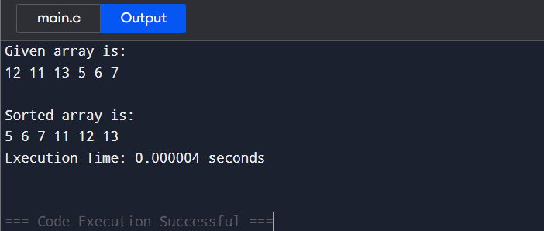

3b quick sort
#include <stdio.h>
#include <time.h>

// Function to swap two elements
void swap(int *a, int *b) {
int temp = *a;
*a = *b;
*b = temp;
}

// Function to partition the array
int partition(int arr[], int low, int high) {
int pivot = arr[high];
int i = (low - 1);
for (int j = low; j <= high - 1; j++) {
if (arr[j] <= pivot) {
i++;
swap(&arr[i], &arr[j]);
}
}
swap(&arr[i + 1], &arr[high]);
return (i + 1);
}

// Function to perform Quick Sort
void quickSort(int arr[], int low, int high) {
if (low < high) {
int pIndex = partition(arr, low, high);
quickSort(arr, low, pIndex - 1);
quickSort(arr, pIndex + 1, high);
}
}

// Function to print an array
void printArray(int arr[], int size) {
for (int i = 0; i < size; i++)
printf("%d ", arr[i]);
printf("\n");
}

// Main function
int main() {
int arr[] = {10, 7, 8, 9, 1, 5};
int n = sizeof(arr) / sizeof(arr[0]);
clock_t start, end;
double cpu_time_used;

printf("Original array:\n");
printArray(arr, n);

start = clock();
quickSort(arr, 0, n - 1);
end = clock();

cpu_time_used = ((double)(end - start)) / CLOCKS_PER_SEC;

printf("\nSorted array:\n");
printArray(arr, n);
printf("Execution Time: %f seconds\n", cpu_time_used);

return 0;
}
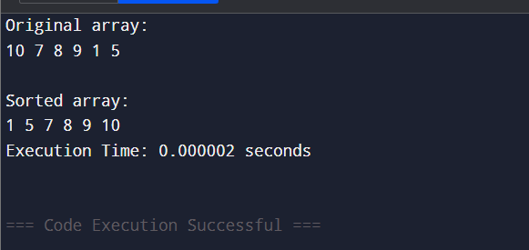

EXPERIMENT 4
N QUEEN
#include <stdio.h>
#include <stdbool.h>
#include <time.h>
#define N 8
void printSolution(int board[N][N])
{
int i, j;
for (i = 0; i < N; i++)
{
for (j = 0; j < N; j++)
{
printf("%c ", board[i][j] ? 'Q' : '.');
}
printf("\n");
}
printf("\n");
}

bool isSafe(int board[N][N], int row, int col)
{
int i, j;

for (i = 0; i < col; i++)
if (board[row][i])
return false;

for (i = row, j = col; i >= 0 && j >= 0; i--, j--)
if (board[i][j])
return false;

for (i = row, j = col; i < N && j >= 0; i++, j--)
if (board[i][j])
return false;

return true;
}

bool solveNQUtil(int board[N][N], int col)
{

if (col >= N)
return true;

for (int i = 0; i < N; i++)
{
if (isSafe(board, i, col))
{
board[i][col] = 1;

if (solveNQUtil(board, col + 1))
return true;

board[i][col] = 0;
}
}
return false;
}

void solveNQ()
{
int board[N][N] = {0};

if (!solveNQUtil(board, 0))
{
printf("Solution does not exist.\n");
return;
}

printSolution(board);
}

int main()
{
clock_t start, end;
double cpu_time_used;

start = clock();

solveNQ();

end = clock();
cpu_time_used = ((double)(end - start)) / CLOCKS_PER_SEC;

printf("Time Complexity: O(N!)\n");
printf("Space Complexity: O(N^2)\n");
printf("Execution Time: %f seconds\n", cpu_time_used);

return 0;
}

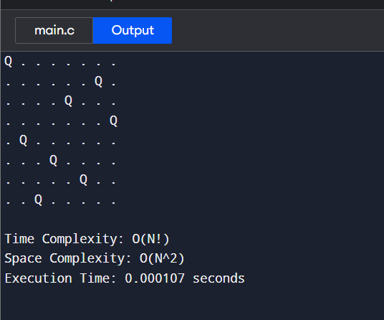

EXPERIMENT 5
SUBSET
#include <stdio.h>
#include <time.h>
void findSubset(int set[], int subset[], int n, int index, int target, int currentSum) {
if (currentSum == target) {
printf("Subset found: ");
for (int i = 0; i < index; i++) {
printf("%d ", subset[i]);
}
printf("\n");
return;
}
if (currentSum > target || n == 0) {
return;
}
subset[index] = set[0];
findSubset(set + 1, subset, n - 1, index + 1, target, currentSum + set[0]);

findSubset(set + 1, subset, n - 1, index, target, currentSum);
}
int main() {
int n, target;
clock_t start, end;
double cpu_time_used;
printf("Enter the number of elements in the set: ");
scanf("%d", &n);
int set[n], subset[n];
printf("Enter the elements of the set: ");
for (int i = 0; i < n; i++) {
scanf("%d", &set[i]);
}
printf("Enter the target sum: ");
scanf("%d", &target);
printf("\nSubsets with sum %d:\n", target);
start = clock();
findSubset(set, subset, n, 0, target, 0);
end = clock();
cpu_time_used = ((double)(end - start)) / CLOCKS_PER_SEC;
printf("\nTime Complexity (Execution Time): %.6f seconds\n", cpu_time_used);
return 0;
}
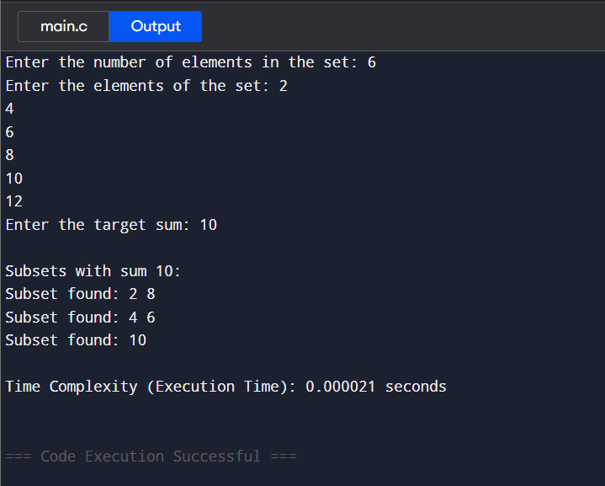

EXPERIMENT 6
6A) Knapsack
#include <stdio.h>
#include <time.h>

int max(int a, int b) {
return (a > b) ? a : b;
}

int knapsack(int W, int wt[], int val[], int n) {
int i, w;
int knap[n + 1][W + 1];

for (i = 0; i <= n; i++) {
for (w = 0; w <= W; w++) {
if (i == 0 || w == 0)
knap[i][w] = 0;
else if (wt[i - 1] <= w)
knap[i][w] = max(val[i - 1] + knap[i - 1][w - wt[i - 1]], knap[i - 1][w]);
else
knap[i][w] = knap[i - 1][w];
}
}

return knap[n][W];
}

int main() {
clock_t start, end;
double cpu_time_used;

int val[] = {60, 100, 120};
int wt[] = {10, 20, 30};
int W = 50;
int n = sizeof(val) / sizeof(val[0]);

start = clock();
int result = knapsack(W, wt, val, n);
end = clock();

cpu_time_used = ((double)(end - start)) / CLOCKS_PER_SEC;

printf("The maximum value that can be put in the knapsack is: %d\n", result);
printf("Execution time: %.6f seconds\n", cpu_time_used);

return 0;
}
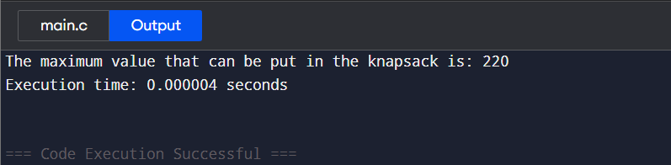

6b) FractionalKnapsack
#include <stdio.h>
#include <stdlib.h>
#include <time.h>

typedef struct {
int itemId;
int weight;
int profit;
float pByw;
} Item;

int compareItems(const void *a, const void *b) {
Item *itemA = (Item *)a;
Item *itemB = (Item *)b;
if (itemA->pByw < itemB->pByw) return 1;
if (itemA->pByw > itemB->pByw) return -1;
return 0;
}

float fractionalKnapsack(Item *items, int n, int capacity) {
qsort(items, n, sizeof(Item), compareItems);
float totalProfit = 0.0;
int currentWeight = 0;

for (int i = 0; i < n; i++) {
if (currentWeight + items[i].weight <= capacity) {
currentWeight += items[i].weight;
totalProfit += items[i].profit;
printf("Added item %d completely. Current weight: %d, Total profit: %.2f\n",
items[i].itemId, currentWeight, totalProfit);
} else {
float remainingCapacity = capacity - currentWeight;
float fraction = remainingCapacity / items[i].weight;
totalProfit += fraction * items[i].profit;
currentWeight += remainingCapacity;
printf("Added %.2f%% of item %d. Current weight: %d, Total profit: %.2f\n",
fraction * 100, items[i].itemId, currentWeight, totalProfit);
break;
}
}
return totalProfit;
}

int main() {
clock_t start, end;
double cpu_time_used;

int n, knapsackCapacity;
printf("Enter the number of items: ");
scanf("%d", &n);

Item *items = (Item *)malloc(sizeof(Item) * n);
if (items == NULL) {
printf("Memory allocation failed.\n");
return 1;
}

printf("Enter itemId, weight, and profit for each item:\n");
for (int i = 0; i < n; i++) {
scanf("%d %d %d", &items[i].itemId, &items[i].weight, &items[i].profit);
items[i].pByw = (float)items[i].profit / items[i].weight;
}
printf("Enter the knapsack capacity: ");
scanf("%d", &knapsackCapacity);
start = clock();
float maxProfit = fractionalKnapsack(items, n, knapsackCapacity);
end = clock();
cpu_time_used = ((double)(end - start)) / CLOCKS_PER_SEC;
printf("\nMaximum profit for the given capacity: %.2f\n", maxProfit);
printf("Execution time: %.6f seconds\n", cpu_time_used);

free(items);
return 0;
}
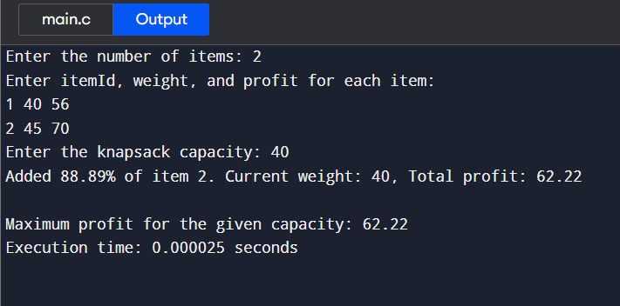

EXPERIMENT 7
7A) Finding Fibonacci Series
#include <stdio.h>
#include <time.h>

int main() {
int n, t1 = 0, t2 = 1, nextterm;
clock_t start, end;
double cpu_time_used;

start = clock();

printf("Enter the number of terms: ");
scanf("%d", &n);
printf("Fibonacci Series: %d %d ", t1, t2);

for (int i = 3; i <= n; i++) {
nextterm = t1 + t2;
printf("%d ", nextterm);
t1 = t2;
t2 = nextterm;
}

end = clock();
cpu_time_used = ((double)(end - start)) / CLOCKS_PER_SEC;

printf("\nExecution Time: %f seconds", cpu_time_used);
printf("\nResult: The code has been executed successfully.\n");

return 0;
}
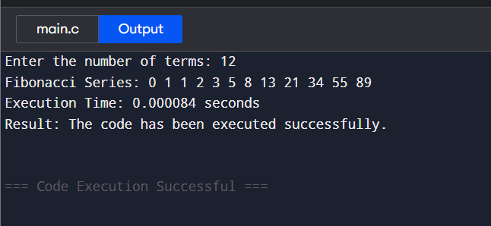

7B) Longest Common Subsequence
#include <stdio.h>
#include <string.h>
#include <time.h>

int max(int a, int b) {
return (a > b) ? a : b;
}

int lcs(char *X, char *Y, int m, int n) {
int L[m + 1][n + 1];
for (int i = 0; i <= m; i++) {
for (int j = 0; j <= n; j++) {
if (i == 0 || j == 0)
L[i][j] = 0;
else if (X[i - 1] == Y[j - 1])
L[i][j] = L[i - 1][j - 1] + 1;
else
L[i][j] = max(L[i - 1][j], L[i][j - 1]);
}
}

int index = L[m][n];
char lcs[index + 1];
lcs[index] = '\0';
int i = m, j = n;

while (i > 0 && j > 0) {
if (X[i - 1] == Y[j - 1]) {
lcs[index - 1] = X[i - 1];
i--;
j--;
index--;
} else if (L[i - 1][j] > L[i][j - 1])
i--;
else
j--;
}

printf("Longest Common Subsequence: %s", lcs);
return L[m][n];
}

int main() {
char X[100], Y[100];
clock_t start, end;
double cpu_time_used;

printf("Enter the first string: ");
scanf("%s", X);
printf("Enter the second string: ");
scanf("%s", Y);
start = clock();
int m = strlen(X);
int n = strlen(Y);
int length = lcs(X, Y, m, n);
end = clock();
cpu_time_used = ((double)(end - start)) / CLOCKS_PER_SEC;
printf("\nLength of LCS: %d", length);
printf("\nExecution Time: %f seconds", cpu_time_used);
printf("\nResult: The code has been executed successfully.\n");

return 0;
}
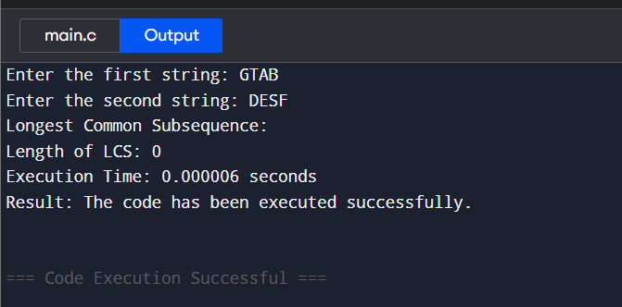
EXPERIMENT 8
Convex Hull
#include <stdio.h>
#include <stdlib.h>
#include <time.h>

typedef struct
{
int first;
int second;
} Pair;

Pair mid;

int quad(Pair p)
{
if (p.first >= 0 && p.second >= 0)
return 1;
if (p.first <= 0 && p.second >= 0)
return 2;
if (p.first <= 0 && p.second <= 0)
return 3;
return 4;
}

int orientation(Pair a, Pair b, Pair c)
{
int res = (b.second - a.second) * (c.first - b.first) -
(c.second - b.second) * (b.first - a.first);

if (res == 0)
return 0;
if (res > 0)
return 1;
return -1;
}

int compare(const void *p1, const void *q1)
{
Pair *p = (Pair *)p1;
Pair *q = (Pair *)q1;

Pair p_diff = {p->first - mid.first, p->second - mid.second};
Pair q_diff = {q->first - mid.first, q->second - mid.second};

int one = quad(p_diff);
int two = quad(q_diff);

if (one != two)
return (one < two) ? -1 : 1;

return (p_diff.second * q_diff.first < q_diff.second * p_diff.first) ? -1 : 1;
}

Pair *merger(Pair *a, int n1, Pair *b, int n2, int *ret_size)
{
int ia = 0, ib = 0;
for (int i = 1; i < n1; i++)
if (a[i].first > a[ia].first)
ia = i;

for (int i = 1; i < n2; i++)
if (b[i].first < b[ib].first)
ib = i;

int inda = ia, indb = ib;
int done = 0;
while (!done)
{
done = 1;
while (orientation(b[indb], a[inda], a[(inda + 1) % n1]) >= 0)
inda = (inda + 1) % n1;

while (orientation(a[inda], b[indb], b[(n2 + indb - 1) % n2]) <= 0)
{
indb = (n2 + indb - 1) % n2;
done = 0;
}
}

int uppera = inda, upperb = indb;
inda = ia;
indb = ib;
done = 0;
while (!done)
{
done = 1;
while (orientation(a[inda], b[indb], b[(indb + 1) % n2]) >= 0)
indb = (indb + 1) % n2;

while (orientation(b[indb], a[inda], a[(n1 + inda - 1) % n1]) <= 0)
{
inda = (n1 + inda - 1) % n1;
done = 0;
}
}

int lowera = inda, lowerb = indb;
Pair *ret = (Pair *)malloc((n1 + n2) * sizeof(Pair));
int ind = uppera;
int k = 0;

ret[k++] = a[uppera];
while (ind != lowera)
{
ind = (ind + 1) % n1;
ret[k++] = a[ind];
}

ind = lowerb;
ret[k++] = b[lowerb];
while (ind != upperb)
{
ind = (ind + 1) % n2;
ret[k++] = b[ind];
}

*ret_size = k;
return ret;
}

Pair *bruteHull(Pair *a, int n, int *ret_size)
{
Pair *ret = (Pair *)malloc(n * sizeof(Pair));
int k = 0;

for (int i = 0; i < n; i++)
{
for (int j = i + 1; j < n; j++)
{
int x1 = a[i].first, x2 = a[j].first;
int y1 = a[i].second, y2 = a[j].second;

int a1 = y1 - y2;
int b1 = x2 - x1;
int c1 = x1 * y2 - y1 * x2;
int pos = 0, neg = 0;

for (int m = 0; m < n; m++)
{
if (a1 * a[m].first + b1 * a[m].second + c1 <= 0)
neg++;
if (a1 * a[m].first + b1 * a[m].second + c1 >= 0)
pos++;
}

if (pos == n || neg == n)
{
int already_added = 0;
for (int l = 0; l < k; l++)
if (ret[l].first == a[i].first && ret[l].second == a[i].second)
already_added = 1;

if (!already_added)
ret[k++] = a[i];

already_added = 0;
for (int l = 0; l < k; l++)
if (ret[l].first == a[j].first && ret[l].second == a[j].second)
already_added = 1;

if (!already_added)
ret[k++] = a[j];
}
}
}

*ret_size = k;
ret = (Pair *)realloc(ret, k * sizeof(Pair));

mid.first = 0;
mid.second = 0;
for (int i = 0; i < k; i++)
{
mid.first += ret[i].first;
mid.second += ret[i].second;
ret[i].first *= k;
ret[i].second *= k;
}

qsort(ret, k, sizeof(Pair), compare);

for (int i = 0; i < k; i++)
{
ret[i].first /= k;
ret[i].second /= k;
}

return ret;
}

Pair *divide(Pair *a, int n, int *ret_size)
{
if (n <= 5)
return bruteHull(a, n, ret_size);

int mid = n / 2;
Pair *left_hull;
Pair *right_hull;
int left_size, right_size;

left_hull = divide(a, mid, &left_size);
right_hull = divide(a + mid, n - mid, &right_size);

return merger(left_hull, left_size, right_hull, right_size, ret_size);
}

int main()
{
clock_t start, end;
double cpu_time_used;

Pair a[] = {{0, 0}, {1, -4}, {-1, -5}, {-5, -3}, {-3, -1},
{-1, -3}, {-2, -2}, {-1, -1}, {-2, -1}, {-1, 1}};
int n = sizeof(a) / sizeof(a[0]);

start = clock();

qsort(a, n, sizeof(Pair), compare);
int ret_size;
Pair *ans = divide(a, n, &ret_size);

printf("Convex Hull Points:\n");
for (int i = 0; i < ret_size; i++)
printf("%d %d\n", ans[i].first, ans[i].second);

end = clock();
cpu_time_used = ((double)(end - start)) / CLOCKS_PER_SEC;

printf("\nTime Complexity: O(n log n)\n");
printf("Execution Time: %f seconds\n", cpu_time_used);

free(ans);
return 0;
}
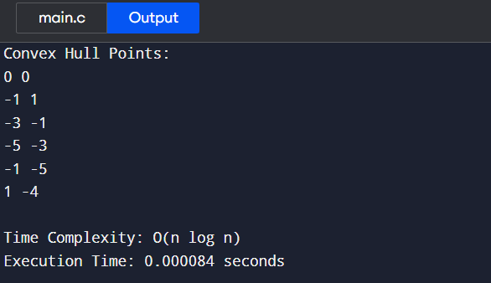

EXPERIMENT 9
Kruskal’s Algorithm
#include <stdio.h>
#include <stdlib.h>
#include <time.h> // for execution time measurement

int i, j, k, a, b, u, v, n, ne = 1;
int min, mincost = 0, cost[9][9], parent[9];

int find(int);
int uni(int, int);

int main()
{
clock_t start, end; // variables for timing
double cpu_time_used;

printf("Kruskal's algorithm in C\n");
printf("========================\n");

printf("Enter the no. of vertices:\n");
scanf("%d", &n);

printf("\nEnter the cost adjacency matrix:\n");
for (i = 1; i <= n; i++)
{
for (j = 1; j <= n; j++)
{
scanf("%d", &cost[i][j]);
if (cost[i][j] == 0)
cost[i][j] = 999; // replace 0 with infinity
}
}

// Start measuring time
start = clock();

printf("\nThe edges of Minimum Cost Spanning Tree are:\n");
while (ne < n)
{
for (i = 1, min = 999; i <= n; i++)
{
for (j = 1; j <= n; j++)
{
if (cost[i][j] < min)
{
min = cost[i][j];
a = u = i;
b = v = j;
}
}
}

u = find(u);
v = find(v);

if (uni(u, v))
{
printf("%d edge (%d,%d) = %d\n", ne++, a, b, min);
mincost += min;
}

cost[a][b] = cost[b][a] = 999; // remove used edge
}

end = clock(); // stop time

cpu_time_used = ((double)(end - start)) / CLOCKS_PER_SEC;

printf("\nMinimum cost = %d\n", mincost);
printf("Execution Time: %f seconds\n", cpu_time_used);

return 0;
}

int find(int i)
{
while (parent[i])
i = parent[i];
return i;
}

int uni(int i, int j)
{
if (i != j)
{
parent[j] = i;
return 1;
}
return 0;
}
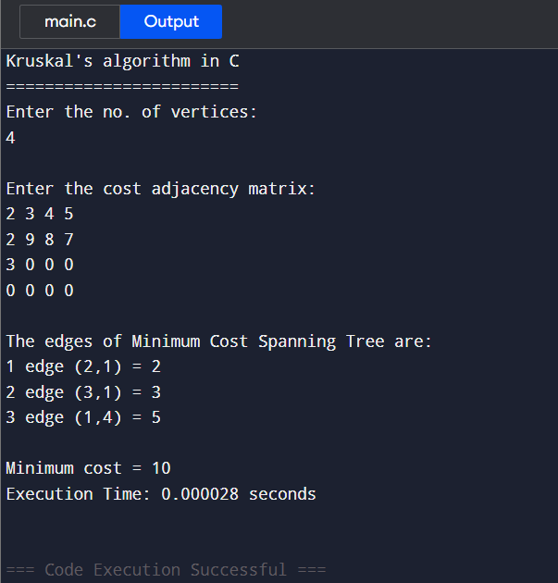

9B) Dijkstra’s Algorithm
#include <stdio.h>
#include <stdlib.h>
#include <time.h> // for execution time measurement

#define INFINITY 9999
#define MAX 10

void dijkstra(int G[MAX][MAX], int n, int startnode);

int main()
{
int G[MAX][MAX], i, j, n, u;
clock_t start, end;
double cpu_time_used;

printf("Dijkstra's Algorithm in C\n");
printf("=========================\n");

printf("Enter no. of vertices: ");
scanf("%d", &n);

printf("\nEnter the adjacency matrix:\n");
for (i = 0; i < n; i++)
for (j = 0; j < n; j++)
scanf("%d", &G[i][j]);

printf("\nEnter the starting node: ");
scanf("%d", &u);

start = clock(); // start timing

dijkstra(G, n, u);

end = clock(); // end timing

cpu_time_used = ((double)(end - start)) / CLOCKS_PER_SEC;
printf("\n\nExecution Time: %f seconds\n", cpu_time_used);

return 0;
}

void dijkstra(int G[MAX][MAX], int n, int startnode)
{
int cost[MAX][MAX], distance[MAX], pred[MAX];
int visited[MAX], count, mindistance, nextnode, i, j;

// Create cost matrix
for (i = 0; i < n; i++)
for (j = 0; j < n; j++)
if (G[i][j] == 0)
cost[i][j] = INFINITY;
else
cost[i][j] = G[i][j];

// Initialize pred[], distance[], and visited[]
for (i = 0; i < n; i++)
{
distance[i] = cost[startnode][i];
pred[i] = startnode;
visited[i] = 0;
}

distance[startnode] = 0;
visited[startnode] = 1;
count = 1;

while (count < n - 1)
{
mindistance = INFINITY;

// Find the next node with the smallest distance
for (i = 0; i < n; i++)
if (distance[i] < mindistance && !visited[i])
{
mindistance = distance[i];
nextnode = i;
}

visited[nextnode] = 1;

// Update distances of neighboring nodes
for (i = 0; i < n; i++)
if (!visited[i])
if (mindistance + cost[nextnode][i] < distance[i])
{
distance[i] = mindistance + cost[nextnode][i];
pred[i] = nextnode;
}

count++;
}

// Print results
for (i = 0; i < n; i++)
{
if (i != startnode)
{
printf("\nDistance of node %d = %d", i, distance[i]);
printf("\nPath = %d", i);

j = i;
do
{
j = pred[j];
printf(" <- %d", j);
} while (j != startnode);
}
}
}
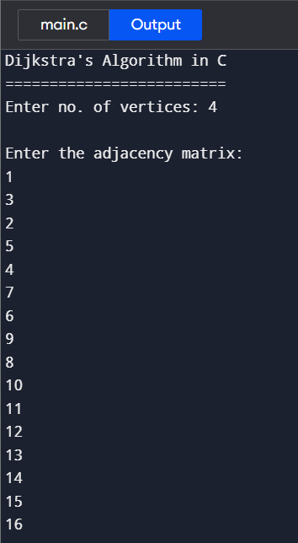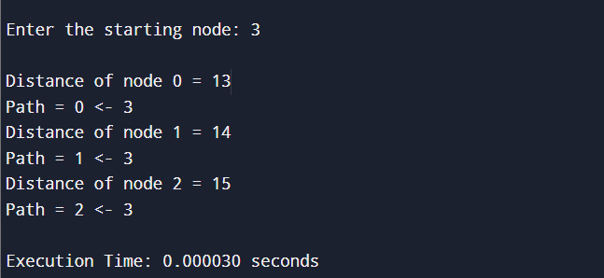

9 Miller-Rabin Test
#include <stdio.h>
#include <stdlib.h>
#include <time.h>

// Function to perform modular exponentiation
long long power_mod(long long base, long long exp, long long mod) {
long long result = 1;
base = base % mod;
while (exp > 0) {
if (exp % 2 == 1)
result = (result * base) % mod;
exp = exp >> 1;
base = (base * base) % mod;
}
return result;
}

// Miller-Rabin test for one iteration
int miller_rabin_test(long long n, long long d) {
long long a = 2 + rand() % (n - 4);
long long x = power_mod(a, d, n);

if (x == 1 || x == n - 1)
return 1;

while (d != n - 1) {
x = (x * x) % n;
d *= 2;

if (x == 1)
return 0;
if (x == n - 1)
return 1;
}

return 0;
}

// Miller-Rabin Primality Test
int is_prime(long long n, int k) {
if (n <= 1 || n == 4) return 0;
if (n <= 3) return 1;

long long d = n - 1;
while (d % 2 == 0)
d /= 2;

for (int i = 0; i < k; i++)
if (!miller_rabin_test(n, d))
return 0;

return 1;
}

int main() {
long long n;
int k = 5; // number of iterations for accuracy
clock_t start, end;
double cpu_time_used;

printf("Enter a number to check if it is prime: ");
scanf("%lld", &n);

srand(time(0)); // initialize random seed

start = clock(); // start timing

if (is_prime(n, k))
printf("%lld is a prime number.\n", n);
else
printf("%lld is not a prime number.\n", n);

end = clock(); // end timing
cpu_time_used = ((double)(end - start)) / CLOCKS_PER_SEC;

printf("Execution Time: %f seconds\n", cpu_time_used);

return 0;
}
